Kenneth Branagh, Renaissance Man? A symposium.
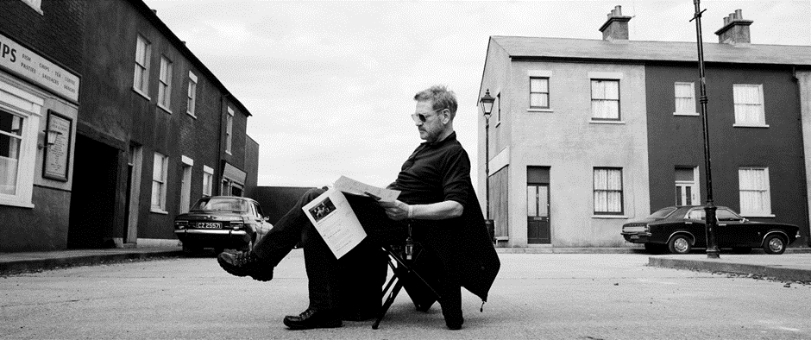
The symposium was held on Wednesday 22nd June at Queen’s University Belfast, and organised by Jennifer Barnes (Dundee University), Katerina Flint-Nicol (QUB), and Fiona Handyside (Exeter University).
Final report for BAFTSS Event Grant Scheme.
This one-day symposium on the cinema of Kenneth Branagh, inspired by the recent release of Belfast (2021), provided a unique opportunity to take stock of Branagh’s film oeuvre from various perspectives and approaches through a series of papers and associated discussion. This event opened proper the previous evening with a public screening of Branagh’s Much Ado About Nothing (1993) at the QFT Belfast, introduced with affection by Fiona Handyside and well attended by both symposium speakers and the public. The screening reminded us all of the promise in Branagh’s early films and the joy in collaboration Branagh brought to his filmmaking. The unabashed infectious summer feel of the film left the audience feeling somewhat sunlight and provided a most suitable start to appraising Branagh’s film works, with many speakers wanting to immediately discuss the film before leaving the theatre.
The symposium brought together scholars, both established and those new to considering Kenneth Branagh’s films, to appraise his directorial career and the tensions in his status across British, Irish, and Hollywood industries. The breadth of focus across the papers illuminated the multifaceted richness of Branagh’s identity as a site of academic exploration, and contribution to cinema as actor, director, writer, and star, as well as highlighting avenues on which to develop and broaden existing scholarship. The symposium structure followed the usual panel format. However, a more organic framework developed on the day to allow for a collaborative approach, with discussions often taking place after papers, presenting opportunities for audience participation and the sharing of ideas and approaches, beyond that of a Q&A formula. Both the participants and those in the audience appreciated and warmed to the supportive atmosphere where perspectives and knowledge were workshopped and exchanged to understand overlapping themes between papers and to identify the more critical aspects to Branagh’s cinema and where potential future scholarship could focus and advance.
The first speaker, Sarah Hatchuel, Professor of Film and Media Studies at the University Paul-Valéry Montpellier 3 participating online, set the bar for the day with a paper on ‘Kenneth Branagh’s Belfast (2021): auto-fiction, adaptation, seed’. The paper located Branagh as both author and subject of the film in considering its explicit but complex autobiographical presentation through the literary concept of autofiction. Drawing upon Branagh’s literary output the play, Public Enemy (1988) and autobiography, Beginning (1989), the paper argued for Belfast as a form of adaptation of these works. This approach was enthusiastically received by the audience and created a lengthy discussion with detailed contributions on the value of this approach from Mark Burnett, Professor of Renaissance Studies, and Director of the Kenneth Branagh archives at QUB.
The second speaker was Lucy Bolton, Reader in Film Studies, Queen Mary University of London, with the paper, ‘My Week with Marilyn: Olivier and Branagh’. Unfortunately, Lucy was ill with Covid and unable to travel. However, despite being ill, Lucy sent a recorded presentation with initial considerations on the persistent comparative relationship of the careers and performances between Lawrence Olivier and Branagh as explored in the case study of My Week with Marilyn. The paper opened up questions as to the motivation of Branagh in taking the role of Olivier, the star Branagh equally distances himself from but drawn towards.
The next speaker, Lavinia Brydon Senior Lecturer in Film at the University of Kent with a paper, ‘Oddities in the Oeuvre? Considerations of Kenneth Branagh’s short films’ reminded participants Branagh has not confined himself to producing feature films. Focusing on Listening (2003) and Swan Song (1992), the paper highlighted how Branagh turns to making short features at particular points in his career, such as after the commercial and critical failure of Love Labour’s Lost (2000), and posited Branagh uses the form of the short film to develop and sharpen his filmmaking practice.
Sahar Hamzah, Assistant Professor in the Jack J. Valenti School of Communication at the University of Houston, is primarily interested in the films of Sir Kenneth Branagh in his post-Shakespeare era and his status as auteur. Sahar’s paper, ‘An Exploration of the Use of Mise-en-Scène to Create Power in Sir Kenneth Branagh’s Murder on the Orient Express and Death on the Nile’, shifted the focus of the symposium to the more popular end of Branagh’s films and to the filmic strategies of Branagh’s directing style as signifiers of authorship. Focusing on composition in the frame and choice of shot angles, Sahar considered the significance of how Branagh thinks cinematically in filming characterisation in his Christie adaptations.
The final speaker before breaking for lunch was Emer McHugh, Lecturer in Drama and Theatre Studies at NUI Galway, with a paper ‘Kenneth Branagh, Irishness, and the Shakespeare Industry’ shifting the focus once more to questions and tensions in Branagh’s identity by raising the concern over Branagh’s Irishness. The paper highlighted how ‘being Irish’ has often been something ‘forgotten’ about Branagh, and an identity that Branagh has not always embraced, while making parallels with how Shakespeare is negotiated and made malleable in Irish culture.
The day closed with three speakers, beginning with Jennifer Barnes, Lecturer at the University of Dundee with the paper, ‘‘On the chin’: Kenneth Branagh’s Performance of Failure’. Following on from the Lucy Bolton’s paper on My Week With Marilyn, Jennifer explored the use of prosthetics in Branagh’s performance of Olivier and implications of racism in the reception of Branagh’s identity and performance in the film.
The next speaker, Katerina Flint-Nicol, Lecturer in Film QUB, gave a paper ‘Branagh and his mediocre Hammer: Finding Kenneth in the Frame’ which argued for seeking ways to consider Branagh not as an artist, but as a self-conscious director of popular and genre films, exploring critical reception which rejected Branagh’s abilities as a director.
The final speaker of the day, Fiona Handyside, Professor of Film University of Exeter, brought the day to a close with her paper, ‘Pursuing the Dream of Integration: Musicals and Branagh’. The paper considered Belfast as a musical with the genre’s objectives of spectacle as unifying and utopian function.
The post-lunch session was a trip to the QUB Special Collections for a curated mini exhibition of a selection of material from the living Kenneth Branagh archives. Symposium delegates were introduced to the archives and given time to look over the displayed items, prompting further discussion and ideas on future development of Branagh scholarship. Items included a second draft of the screenplay for Henry V, storyboard for Much Ado About Nothing, campaign book for Dead Again, press clippings for Thor, and artwork from Hamlet. Staff from Special Collections were on hand to answer any questions and also brought marketing material from previous events and conferences on Kenneth Branagh in relation to this theatre work and Shakespeare adaptations. Having an opportunity to view the storyboards for Much Ado…complimented Fiona Handyside’s introduction to the film, as she highlighted the lengthy planning of, and the minutia in the closing scene, and storyboards were an example of where the adaptation process and Branagh’s directorial style intersect.
As many papers invited immediate discussion, time for closing remarks was short. We decided then as a group to conduct closing remarks and a roundup discussion over scheduled drinks in the QFT. We were all enthused by what the day had achieved. The overview from the day for many speakers was the variety and diversity of potential scholarship on Branagh’s film career, and how academic work to date, predominately concentrates on his Shakespeare adaptations and connections to Shakespeare. It was generally felt, no matter what our personal opinions on Branagh’s directorial career, he is a critical site through which to approach the concerns of British cinema and there was genuine excitement as to future events and collaborative projects. The closing discussion remarked on how the symposium presented the opportunity to tease out repeated concerns and themes across Branagh’s film work, such as the objectification of Hollywood either as structural element in his films or as part of his filmmaking practice, an oscillating acknowledgement of his Irishness, a working-relationship with Judi Dench, collaborative filmmaking practices, tensions between Branagh’s film career and stage lineage, and the importance of ‘belonging’ for Branagh. An objective of the symposium was to identify any such connections and overriding themes and concerns to Branagh’s cinema as a way to understand how to develop and shape future scholarship; so, this is one of the successes of the event. As is, a potential network of Branagh film scholars.
There were discussions around potential publications; a special edition for the Journal of British Cinema and Television with articles devoted to Belfast, and an edited collection more broadly on Branagh’s film oeuvre. There was further talk on the possibility of future conferences with a potential for interdisciplinary study.

Report by Katerina Flint-Nicol, Lecturer in Film Studies, Queen’s University Belfast.

